Array Standards

# Images

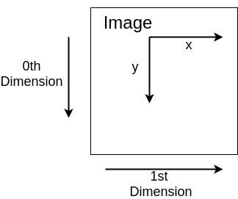

Image data should have shape (H, W, D) where H, W and D are height, width and depth.

The pixel value at (x, y) coordinate can be found by I[y, x, :] for images of multiple depth and I[y, x] for images of single depth

# Points, P

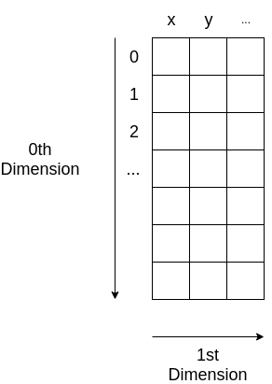 Point data should have shape (N,D) where N is the number of points and D is the number of dimensions.

P[:, 0] should contain x

P[:, 1] should contain y

P[:, 2+] should contain any other dimensions

If needs to be immuatable should be a tuple made by: P = ((x1, y1), (x2, y2), …)

If needs to be mutable should be a list made by: P=[[x1, y1], [x2, y2], ...]